Vulcan Activity Tracker
Weekly Report

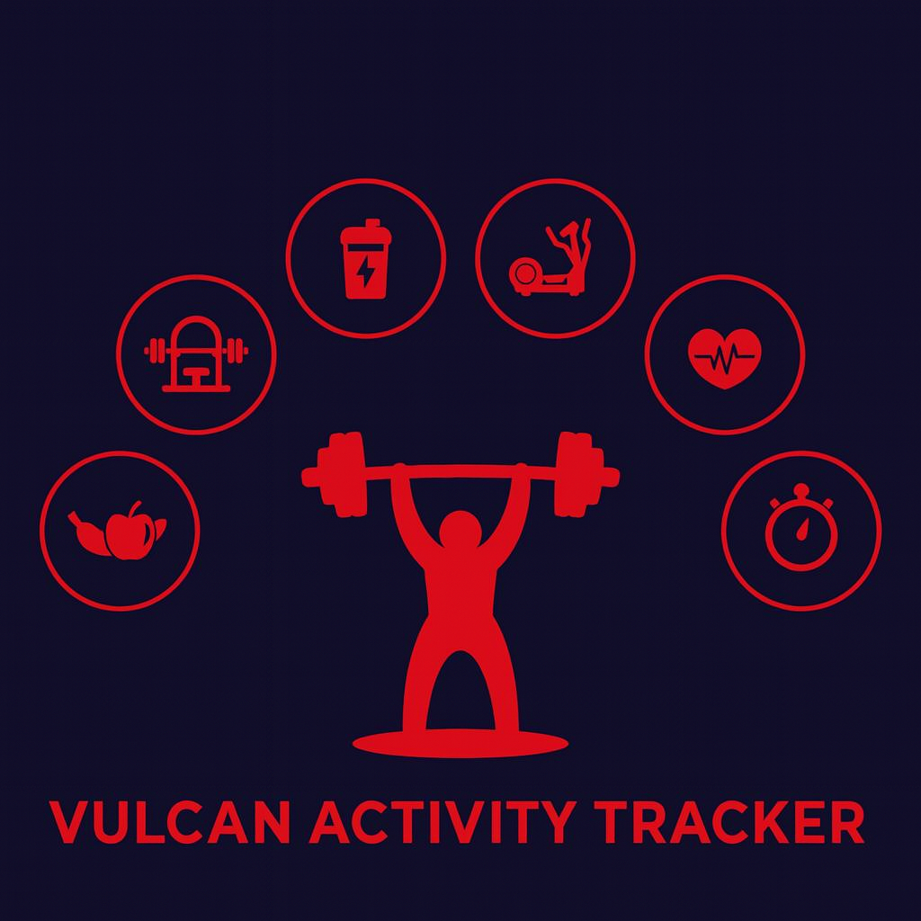

Week 3
Team Members:
Margo Bonal
John Gerega
Luke Ruffing

Professor:
Dr. Weifeng Chen

Course: CMSC-4920-Senior Project II
School: Pennsylvania Western University

Project: Vulcan Activity Tracker
During week 3, our senior project group began to add a database schema for users to upload their logged activities. Throughout the discussion, we decided this was the number one priority to accomplish this week.
Goals Accomplished:
The first goal was to get a user-friendly frontend for users to upload various types of activities. This page has three fields of information that every type of activity will contain: the name of the activity, the date, and the duration of the activity in minutes. A dropdown menu of choices is available to the user, and the fields associated with their choice will appear once they have clicked on it. Once users are done, they click the "Save Activity" button at the bottom of the page to save their choices. Error checking is done to ensure that the required fields contain data.
The second goal was to take the data the user entered in the activity page and upload it into our backend database. To accomplish this, a new table was required in the database for activities, and the program had to extract the active username to ensure the new activity was uploaded to their account.
The third goal was to take the data just uploaded to the database and format it to be shown in a table on the activity page. To accomplish this, the second goal had to be implemented correctly, and then we had to successfully fetch the activity data from the database and place it into a JSON file in order to successfully place it into an HTML table element.
Challenges faced:
In trying to accomplish the second goal, the team ran into some issues. We could not simply hard-code activity data into a Json file as the application accepts various types of activities with different fields (running, biking, sports, etc.). To fix this issue, we had to split the data into two categories: common data that every activity will have, and data specific to that type. Common data was extracted first, then the program ensures the activity-specific data is able to be serialized into JSON.

